**Executive Summary**

* Game Concept:
* Genre/Aesthetic: Dark, horror. From a visual aesthetic standpoint, we wanted it to feel realistic/lifelike to really convey a sense of horror/desperation to survive against the realistic-looking threats.
* Target Audience: Teenagers or older – the visuals are realistic in their portrayal of violence/gore, and the experience might be offsetting for a younger audience. The ideal target audience would be those who love the horror genre (i.e. movies, shows, traditional games) – our game seeks to provide these fanatics with a first person, personalized, interactive horror experience
* Inspiration: Left 4 Dead 2 game
* Story: You’re out on the abandoned streets of a cityscape overrun by destruction and chaos. Although seemingly abandoned, you soon realize there are hostile monsters attempting to kill you. With nowhere to escape to around the streets, you must fend off these bloodthirsty enemies and fight to stay alive.

**Gameplay (explain high-level objectives, game progressions, win/lose conditions, level design, etc.)**

* High-level Objective(s): The user must fight to stay alive as long as possible. In order to do so, they must kill enemies, who drop ammo or health syringes upon their death. Users then can continue healing themselves and further fight enemies once they collect this ammunition and health syringes
* Win/lose conditions: The ultimate losing condition would be the user dying. The win condition, on the other hand, is like that of arcade games in that users can define what they consider a successful run through; players can keep replaying the game to see if they can break their previous time/score record of how long they can stay alive, or even beat the record of their friends.
* Level design: The main level for our game is laid out around a 4-way street intersection. Users can walk down each of these four streets but won’t be able to reach the end of the street because police cars (and rubble) have blocked any space to walk through. Users can find health syringes and ammunition by killing enemies. There are three types of guns users can use: handguns, shotguns, and rifles. These guns are hidden throughout the level, and users can pick up new guns to use once they’re found. Below is a map outlining where all the guns are located in our game (along with the boundaries outlined from a top down view showing the limitations of where users can navigate to:

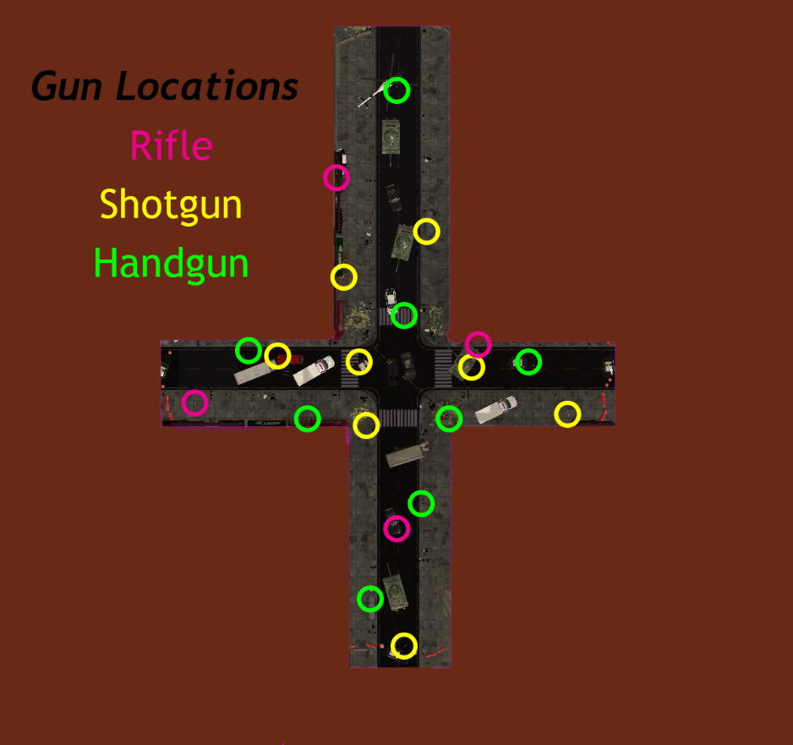

**Mechanics (how low-level things like rules, physics, gameplay, scoring etc. are implemented)**

* Rules:
* Physics:
* Gameplay:
* Scoring:

**User interface (UI) and controls (locomotion strategy, manipulation, what is shown to the user, etc.)**

* Locomotion Strategy:
* UI layout:

**Music and audio (if included)**

* TBD

**A description of the assets you made vs ones you used from other sources (and provide attribution)**

* 3D assets from Unity Asset Store:
  + <https://assetstore.unity.com/packages/3d/vehicles/land/police-car-helicopter-52496>
  + <https://assetstore.unity.com/packages/3d/environments/urban/concrete-plastic-barrier-72966>
  + <https://assetstore.unity.com/packages/3d/vehicles/land/low-poly-city-vehicle-pack-217344>
  + <https://assetstore.unity.com/packages/3d/vegetation/trees/realistic-tree-9-rainbow-tree-54622>
  + <https://assetstore.unity.com/packages/3d/vegetation/trees/mobile-white-birch-tree-281448>
  + <https://assetstore.unity.com/packages/3d/environments/urban/modular-abandoned-slaughterhouse-lite-58082>
  + <https://assetstore.unity.com/packages/3d/props/furniture/key-and-lock-193317>
  + <https://assetstore.unity.com/packages/3d/environments/urban/nyc-block-6-16272>
  + <https://assetstore.unity.com/packages/3d/environments/urban/low-poly-street-pack-67475>
  + <https://assetstore.unity.com/packages/3d/environments/roadways/vehicle-parking-lot-garage-gate-pbr-111423>
  + <https://assetstore.unity.com/packages/3d/props/interior/old-bathroom-objects-120069>
  + <https://assetstore.unity.com/packages/3d/environments/asset-pack-for-horror-game-226196>

**Walkthrough video:**